A Project Proposal on

# “Movie Recommendation System

**– Using Data Science”**

Submitted by

**Piyush Nirbhavane – 19202A0006**

**Shourish Kothawale – 19202A0047**

**Shishir Nath – 19202A0054**

**Shubham Jadhav – 19202A0011**

Head of the Department

**Mrs. Yogita Jore**

**Department of Information Technology**

(NBA Accredited)

**Vidyalankar Polytechnic**

**Wadala (E), Mumbai – 400 037**

**Maharashtra State Board of Technical Education, Mumbai**



**________________________________________________________________**

**Abstract**

We now live in what some call the “era of abundance”. For any given product, there are sometimes thousands of options to choose from. Think of the examples above: streaming videos, social networking, online shopping; the list goes on. Recommender systems help to personalize a platform and help the user find something they like.

The easiest and simplest way to do this is to recommend the most popular items. However, to really enhance the user experience through personalized recommendations, we need dedicated recommender systems.

From a business standpoint, the more relevant products a user finds on the platform, the higher their engagement. This often results in increased revenue for the platform itself. Various sources say that as much as 35–40% of tech giants’ revenue comes from recommendations alone.

**1. Modules / Users / Actors in the Project**

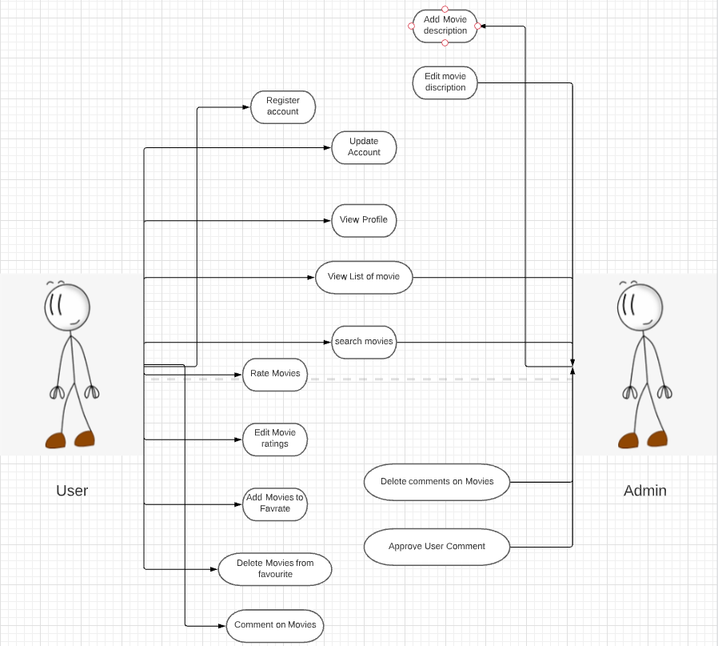

**2. Flow chart / Block Diagram (if any needed to explain the topic)**

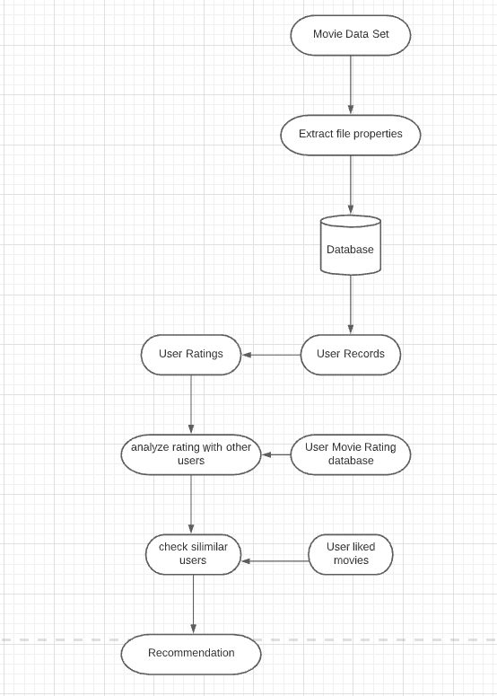

**3. Applications of the project**

* We will also allow users **to create an account on the website**. This account will be used to keep a track of the data.
* It will be beneficial to the streaming services as we will be showing the platform on which the movies are being streamed.
* It will customize user experience
* We’ll be sending monthly mails to the users showing them the new recemented movies along with upcoming movies similar genre

**4. Technologies used for the project.**

* Python for implementation.

* Python Libraries like pandas, matplotlib, seaborn, EDA, sklearn, for manipulating data.

* HTML is used to structure the webpage.

* CSS for styling the webpage

* JavaScript for making the webpage more responsive.

* Jupyter Notebook/Spyder for Data Science and Analysis

* Firebase for Database

**5. Reference Paper (in any)**

**Reference Website:**

<https://research.aimultiple.com/recommendation-system/>